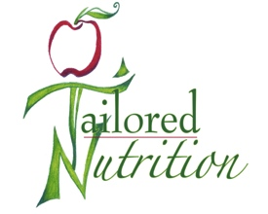
OLIVIA KIRVEN RD, LD

Biography
Olivia Kirven is a registered dietitian currently employed at the Sheridan V.A.M.C and by Tailored Nutrition LLC. She is a Wyoming native who enjoys living next to the beautiful landscape of the Big Horn Mountains. Olivia is dedicated to the profession of dietetics and excited to guide others on their journey to better health.

Education
Olivia earned her bachelor’s degree in Food Science and Human Nutrition at the Colorado State University. She completed her dietetic internship through Meredith College in Raleigh, North Carolina.

Credentials
Olivia is a registered dietitian (RD) and a licensed dietitian (LD) in the state of Wyoming. She is a member of the Academy of Nutrition and Dietetics (AND) and a member of the AND Dietetic Practice Group Dietitians in Integrative and Functional Medicine (DIFM).

Professional Speaking
Olivia developed and presented a variety of presentations while she was completing her dietetic internship. Examples include Hot Topics in Heart Health at University of North Carolina’s Wellness Center in Chapel Hill, NC, Preventing Iron Deficiency Anemia in Children at the Wake County Health Department in Raleigh, NC, and Improving School Nutrition with the Healthy Hunger Free Kids Act 2010 to the internship program’s preceptors.

Services
Olivia has experience conducting nutritional assessments, utilizing medical nutrition therapy, and providing diet education with a client centered approach. She has particular interest in the topics of cardiovascular health, diabetes management, weight management and wellness.

Health Insurance Credentials
She is currently credentialed with Wyoming Blue Cross/Blue Shield.
Olivia is currently in the process of credentialing with EBMS, Aetna, Cigna and Medicare.

